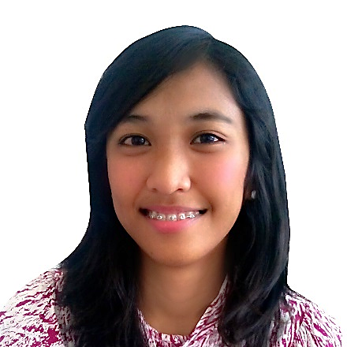**STEFANIE COMAYA SALADA**

Indepencia St., Tacloban City

09092550786herzheiland@gmail.com

**Objective**

To obtain a position where I can use my skills and abilities, training, experience, and educational attainment. Keen to expand my knowledge and skills and to work for a valuable purpose.

**SKILLS AND ABILITIES**

* Have a good interpersonal skills
* Proficient in written and oral communication in English
* Basic research and data analysis, participatory project development, basic communication and presentation, project concept formulation
* Literacy in computer programs such as MS Word, MS Excel, MS PowerPoint, MS Publisher, Adobe Photoshop, CorelDRAW
* Have a sense of commitment and professionalism
* Can organize and facilitate team building activities, workshops, trainings, and seminars.
* Efficient in working under stressful situations and perform multiple-tasks.

**EDUCATION**

2010 - 2014 **University of the Philippines Visayas – Tacloban College**

Bachelor of Arts in Social Science Major in **Economics**

2006 - 2010 **Southern Leyte State University – Tomas Oppus Laboratory High School**

Tomas Oppus Southern Leyte

2000 - 2006 **Bontoc Central School**

Bontoc Southern Leyte

**ORGANIZATIONAL MEMBERSHIP**

2013-2014 **UPVTC Economics Society**

Member

2013-2014 **Junior Philippine Economic Society**

Member

2010 – 2012 **Interactive Society**

Member

2011-2012 **UP InGEN Organization**

President

**WORK EXPERIENCE**

2010 – *Present* **Technical Crew Volunteer,** Tacloban Bible Community

Design posters/tarpaulins for special occasions or events. Operate computer for visual presentation during events. Camerawoman for special events i.e. concerts, seminars, etc.

**SEMINARS ATTENDED AND CO-CONDUCTED**

2014 **Economic Paper Presentation: Undergraduate Researches**AS Room 22, UP Tacloban

2014 **Financial Literacy: Investing for the Future**Multi-Purpose Building, UP Tacloban

**TRAININGS**

2010 **Post Encounter Class**

2011 **School of Leaders 1**

2011 **School of Leaders 2**

2011 **School of Leaders 3**

**RESEARCH PAPER PREPARED**

2014 **“Assessment of the Impacts of Super Typhoon Yolanda (Haiyan) on the Income and Expenditure Patterns of Fishing Households in Bislig, Tanauan, Leyte”**An interviewer-led survey was conducted in order to determine the impact of the devastation caused by the Super Typhoon Yolanda (Haiyan) on the income sources and spending patterns of fishing households in Brgy. Bislig Tanauan Leyte.

**PERSONAL BACKGROUND**

Born on May 31, 1994 in Sogod, Southern Leyte. Fluent in English, Filipino, BIsaya/Cebuano, Waray - waray. Adaptable, goal-oriented and quality-oriented.

**References**

**PROF. ED FIRMO ROQUINO**

Research Adviser

University of the Philippines Visayas Tacloban College

09267004010

**PTR. EDWIN ESPINA**

Senior Pastor

Tacloban Bible Community

09169009152

**CHARLES BORJA**

Operations Assistant

RCBC – Tacloban Branch

09173264013

I hereby attest and certify that all aforementioned information above is true.

STEFANIE C. SALADA

Applicant